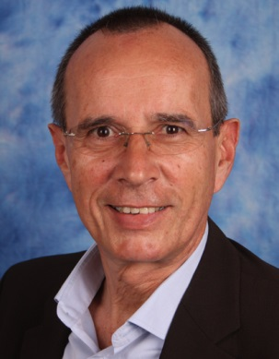
Name Roger Goetzendorff
Adress Max-Born-Weg 37, 85748 Garching
Tel. +49.89.38591227
Mobile +49.172.162.5848
Email roger@goetzendorff.com

PROJECTS – Excerpt
 | 01.04. – 31.09.2018  BDO IT GmbH | Senior Manager ECM&DP  Implementing partner management and introducing professional marketing instruments
 | Jul. 2017 – March 2018  Fondsdepot Bank GmbH Hof | Multi project manager. Vendor Manager.
 | Jan. 2017 – Jun. 2017 | IT-Orga TipTrip e.K. (www.toptrip.biz)
 | Jun. 2014 – Dec. 2016  Unicredit, Munich | Project management, Portfolio management/Asset mgmt. area (TripleA)  Test management: coordination of international test activities regarding MiFID 2
Mar. 2012 – Apr. 2014  PMS Italia, Milano |  | Project management and COO. Main target: develop an intelligent hospital bed and modernize hospital process management
Aug. 2011 – Feb. 2012  MunichRe Munich |  | Project management creating a CALYPSO-based hedging platform
Sept. 2010 – Mar. 2011  Xchanging/Kedrios, Milan |  | International Project for Xchanging/Kedrios, re-platforming IT
2007 - 2010  UniCredit, Munich |  | Project management: IT-Integration of about 150 applications of the Investment Banking, after UniCredit taking over HVB
2000  comdirect Bank, Quickborn and Milan.Online bank |  | Strategic Consulting, Project Management. IT organization. Infrastructure planning of the new comdirect, Milan. Implementation CRM software, Call Center set-up

WORKING EXPERIENCE
Apr. 2018 – 30.09.2018 |  | BDO IT GmbH - Senior Manager ECM & DP
2006 – March 2018 |  | Consultant, owner of InternationalSolutions
1995 - 2006 |  | Head of IT, Partner, IPCSoft s.p.a., Milan, Italy – SW House for Banks and Brokers
1994 |  | Head of IT, DANBIOSIM s.p.a., Milan, Italy – Broker House
1985 -1994 |  | Product responsible AWS GmbH, Munich, Germany – Financial Software House
FUNCTIONAL SKILLS |  | Long term (GT 20 years) experience at international banking and assurance environment.  Execution of several, some very high budgeted, IT projects, involving all business areas. Deep knowledge of all financial institutions processes
IT SKILLS |  | Many years of experience in many areas.
DATE OF BIRTH |  | 1959
EDUCATION
1976 – 1985 |  | Electrical engineering at Technical University Munich, Aerospace at German Federal Armed Forces University Munich, Engineering at polytechnic school of Barcelona
LANGUAGES |  | Mother tongue: German. Fluent: English, Spanish, Italian, and French. Good Catalan. Russian.

